HTML/CSS

1. **<b>** vs **<strong>** b and strong tab both are doing same work but strong means this strong cotted word keeps some strong value in given paragraph. This basically helps search engine to identify strong word.
2. **<i>** vs **<em>** Both does same work but em tag means this word has some value so emphasis this word.
3. **<small>** this tag is used for make the text small.
4. **<mark>** this tag is used to highlight text in yellow.
5. **<del>** this tag is used to strike the word to mark deleted.
6. **<ins>** this is used to show text has inserted and text will be visible as underline.
7. **<sub>** to show X2 => X<sub>2</sub>
8. **<sup>** to show Y2 => Y<sup>2</sup>
9. **<q>** Quotation
10. **<**blockquote cite=”www.google.com”**>** to show some specific author quote.
11. **<abbr title=”World health Organization”>**WHO**</abbr>**
12. <address>
13. <cite>The Lost kid</cite> is written by…. This generally used to show book name.
14. <a href=””></a> this tag having multiple attributes like **target=”blank”** this attribute **opens link in new tab** **and title=”Go to next line”** to **show some hint**. For navigate to same page first we will have to define that particular <p id=”localPara”> then we need to write anchor tag something like <a href=”#localPara”</a>
15. On click of some link if we want to open email app where value will be auto fill and subject also then we will have to write something like:

<p>Contact us on <a href=”**mailto:admin@website.com**”> [admin@website.com </p](mailto:admin@website.com%20%3c/p)>

And we want to add subject as well then <p>Contact us on <a href=”**mailto:admin@website.com?subject=hello how are you**”> [admin@website.com </p](mailto:admin@website.com%20%3c/p)>

1. **<img>** This is empty tag, there are below property in img tag:
2. **src**: to specify path
3. **alt**: we specify purpose of image; this property helps in SEO and if image not loaded then this alt text will display
4. **width**: we set width of image in pixels
5. **height**: we set height of image
6. **<marquee>**: Is use to scroll text or image on screen there are below attribute of marquee tag:
7. **direction**: right/left/up/down
8. **<ol>**: ordered list having below attributes:
9. **start**: we can give from where we can start
10. **type: default type is number now suppose if we want to start from capital A then set type as type=’A’ if we want to start from small a then give type type=’a’ or for roman give type=’i’**

**Note: We can make nested list as well means list inside list.**

1. **<ul>:** unordered list having below attributes:

There is not specific attribute for ul list we have to use css style attribute and for list css provides us

1. **list-style-type**: disc;

Now this list-style-type css property has different values:

1. **disc;**
2. circle;
3. sqare;
4. none;
5. list-style-image:url(); => To use image in palace of dot or alpha numeric number
6. list-style-position: inside;
7. **<dl>**: description list is used to define list with description it having below attributes:
8. <dt> to define description list item
9. <dd> to define description of list

Eg: <dl>

<dt>Coffee</dt>

<dd>-Black to drink</dd>

</dl>

1. **<table>**: This tag we use to define a table and it having below following sub tags:
2. <th></th> - table heading
3. <tr></tr> - table row
4. <td></td> - table column
5. <thead></thead>
6. <tbody></tbody>
7. <tfoot></tfoot>

Now this <table> has below attributes:

1. border: this attribute is used to define border width in pixels.
2. Colspan=”2”: this attribute is used with <td> to merge the columns
3. Rowspan=”3”: to combine row this is used with
4. **Structure Elements:**

There are 2 types of structure elements:

1. div: Block elements – A block-level elements always start on a new line and takes up the full width available (stretches out to the left and right as far as it can)

these below tags are block elements:

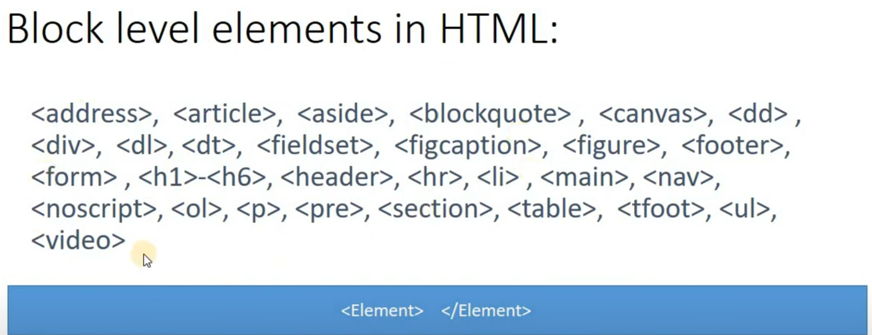

1. span: Inline elements –

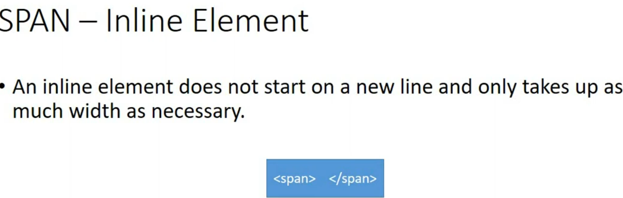

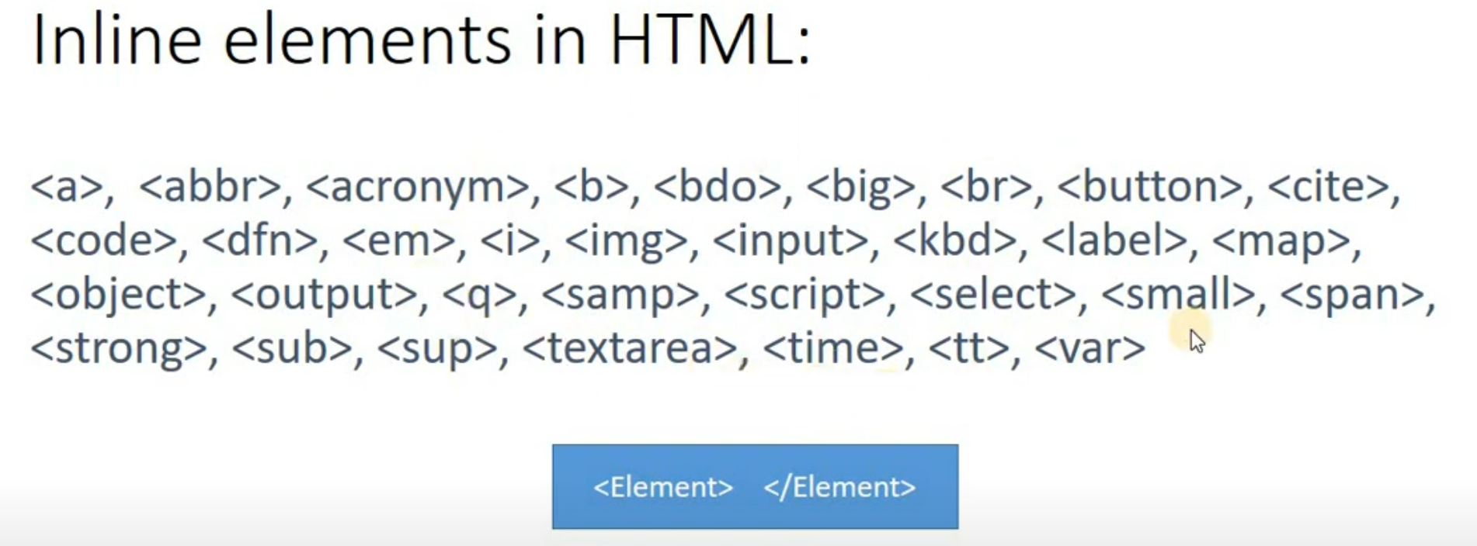

Note div takes 100% width and span takes only required width eg in below screenshot:



1. **iframe**: this tag is used to show one web page inside one web page, the attributes of iframe tag are:
2. scr
3. height
4. width
5. **<audio>** is used to add audios on web page these below attributes:
6. Controls: to show controls

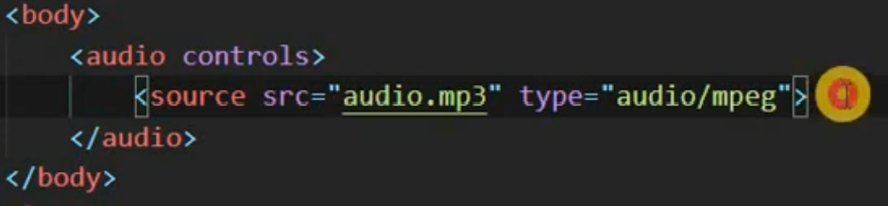

1. <video>: to embed video

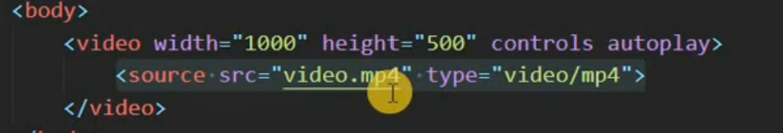

1. There are 3 ways to attach PDF on web page:

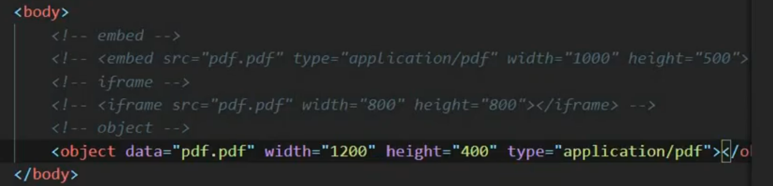

1. To add youtube video on our website just go to youtube website and click on share option and then click on embed option then one link will display just copy that link and paste it on out html page, but that video owner should allow embedding of data.
2. To add google map on our website just go to google map website and select that particular location and click on share button then click on embed and selection option present over there according to our need and then copy the code and page it on our website
3. **Image Map**: To make any part of image clickable: we can do this manually but there as multiple websites where we can upload our image and select respective section and get the code, we can use **imagemap.org**

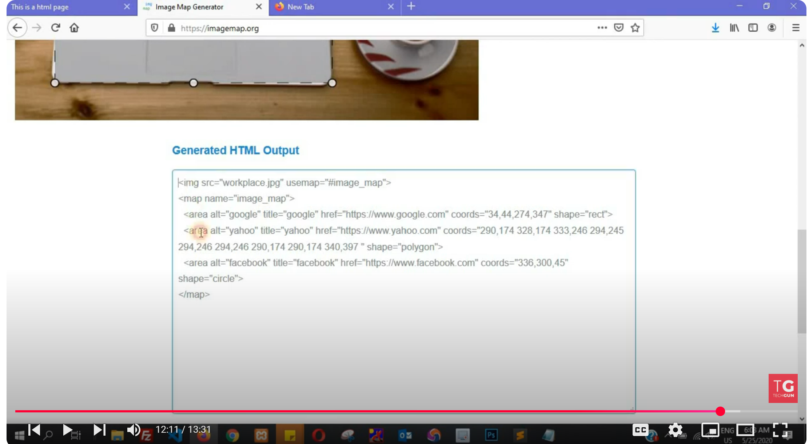

**Forms**

1. **Input**: There is different type of input types:
2. **Text**
3. **Submit**
4. **Color**
5. **Date**
6. **Email**
7. **Hidden**
8. **Number** – (Used attributes min & max and step- to increment by)
9. **Password**
10. **Reset**
11. **Time**
12. **url**
13. **range: <input type=”range” min=”1000” max=”5000”>**

**Note: It is recommended to wrap each input in a div.**

1. **File upload:**

<form enctype=”multipart/form-data”>

<input type=”file” multiple>

</form>

Note: if we will not write multiple option then it will allow only one file to upload.

1. Input attributes: There are various type of input attributes: -
2. value: To set default value
3. readonly: If we will use this attribute then we cannot change the value of input field
4. disabled: To make the input field as disabled
5. size: to fix the size of input showing element means suppose if we put size value as 50 then at a time only 50 characters will be visible rest will be inside input field but it will not be visible
6. maxlength: To fix the input field size means suppose if we keep maxlength as 50 then then only 50-character input fields can take as input
7. placeholder: To give user hints or suggestion
8. required: to make input field mandatory
9. **autofocus**
10. autocomplte = “on”: default value is on. If this attribute is on then browser will give us hint for already used values.
11. Name: to send value to backend.
12. Textarea: in text area to set height and width we can use **rows & cols**(rows=20 and cols=50) and in place of place holder we have to use text between opening and closing tags.

Eg: <textarea rows=”20” cols=”50”>Hello…</textarea>

1. If we want to show image on submit button then we have use image in input type=”image”.

Eg: <input type=”image” src=”…” width=”100” height=”500”>

1. Select:

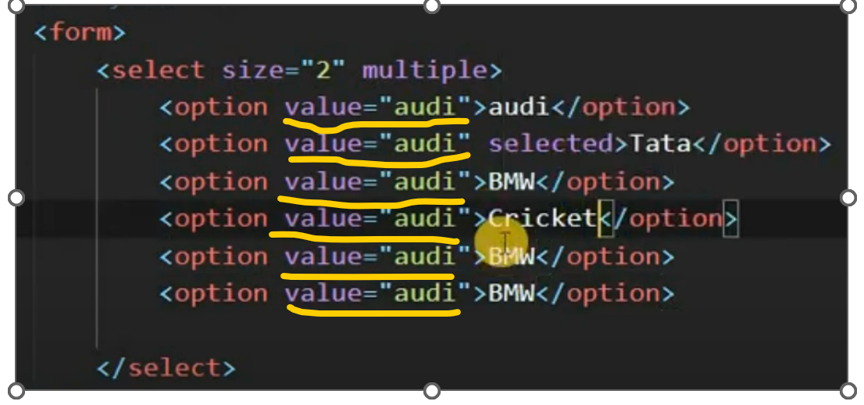

To group:

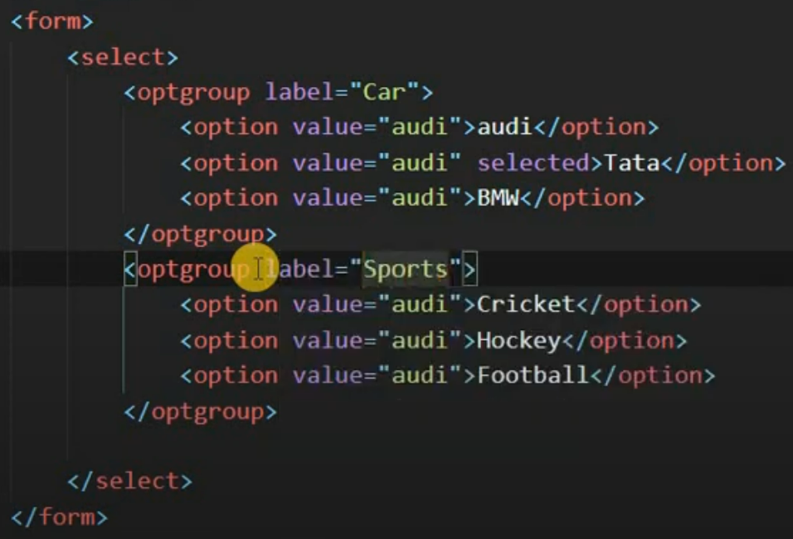

1. Radio button: 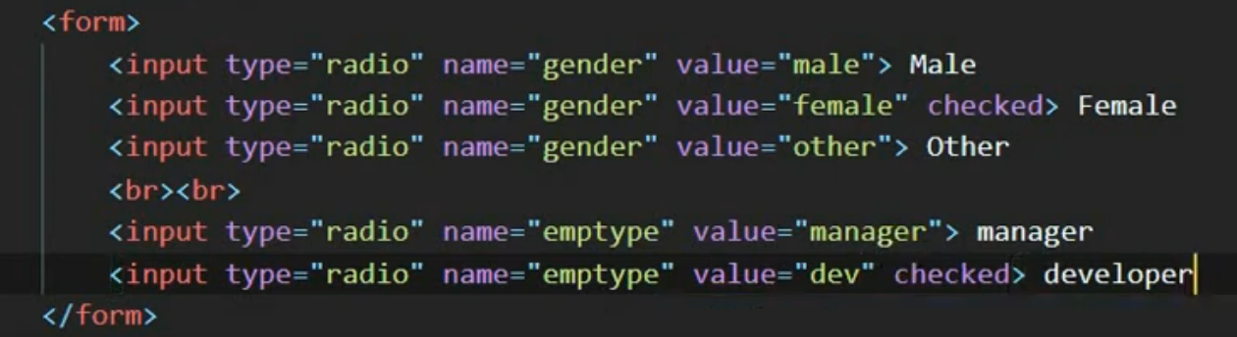
2. Checkbox:

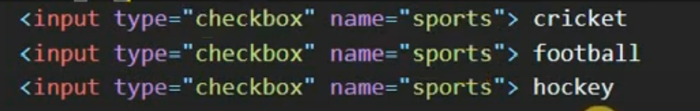

1. Datalist: To show selected data on input text enter:

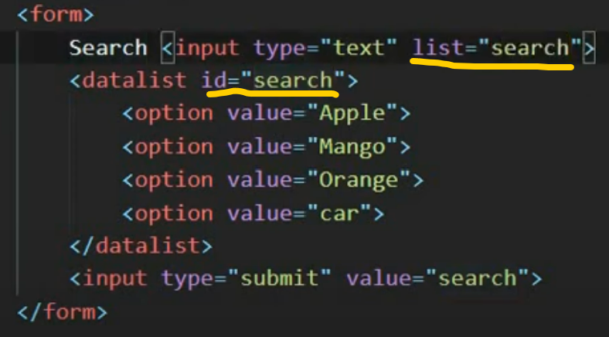

1. **Label: this tag is used to show label on UI for input field, suppose if we clicks on label then cursor should point/land to input text for this, we will have to link label and input text field using id attribute in input field and use this “id” attribute value in label using “for”**

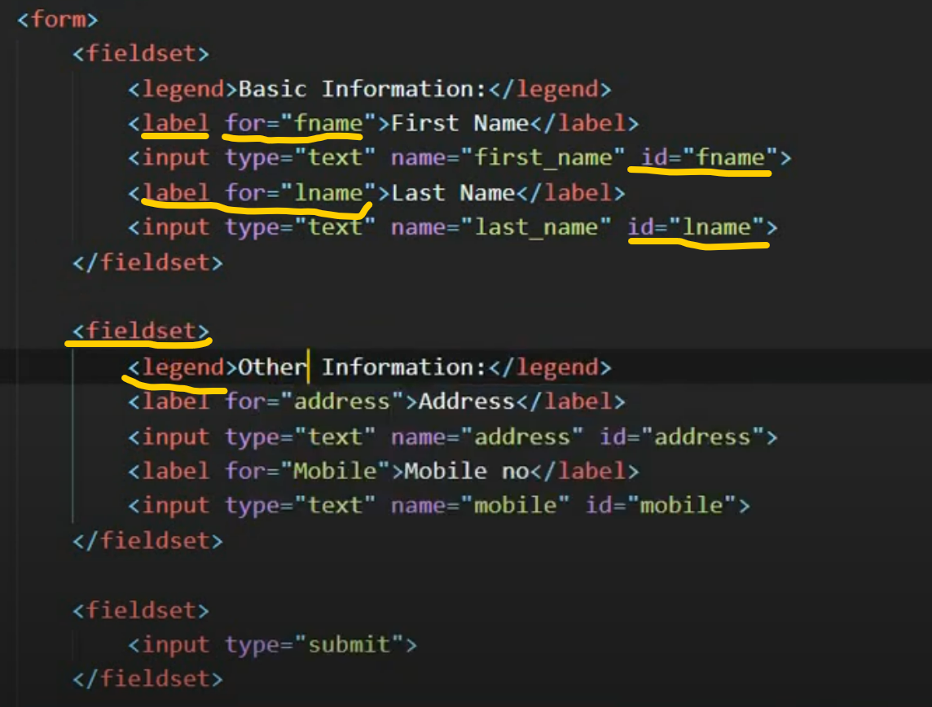

In above image we have used **fieldSet** and **legand**

1. **SEO Tags - Title, Meta Description, canonical, keyword, and robots**

These above tags are used to seo our page. Title is used to show tile of page in browser as well as in search engine heading and this meta description (<meta name=”description” content=”Description of page what is purpose and why”/>) used to show short description of page on search engine mean when if anything we are searching on web page then with each suggestion some tile and description is coming this tile and description referring the same.

Now we have **keyword**: this keyword is used to give search engine keyword to refer page.

**Canonical**: suppose we are making 2 page of one content with 2 different name and google will come to know that you are trying to confuse good then it will not rank your page, so tell google please consider only this page we use canonical property of link.

**Robots**: Using this attribute of meta tag we tell google/search engine that do google need to read this page or not

**<meta name=”robots” content=”index, follow”/>**

If we will specify index and follow then google will index this page and follow all the links

And If set follow as **nofollow** -> then google will not follow the external or other link present on the page.

And if we will use **noIndex** then google will not index that page.

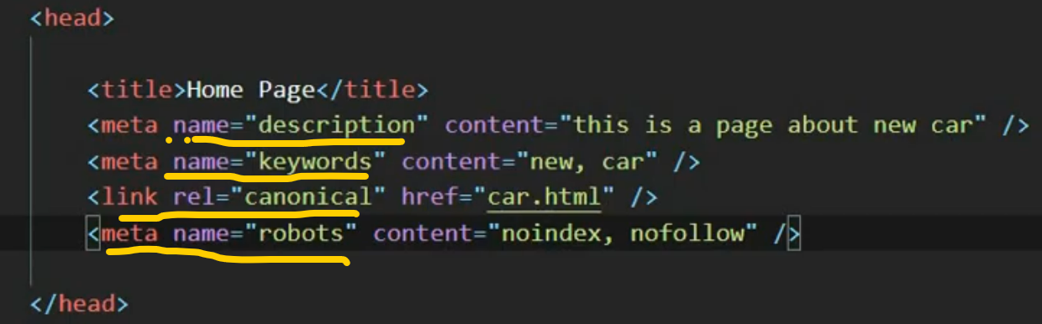

1. Noscript: this tag we are using to show message to user if due to some reason javascript is disable in browser.

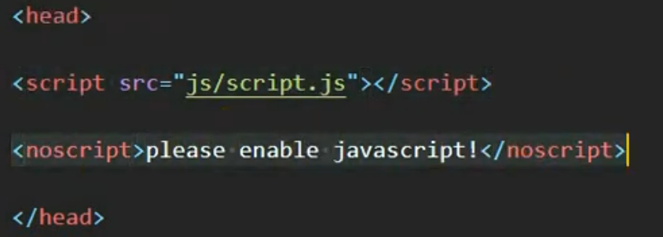

1. **OG Tag, Open Graph Tags and Twitter card tags**

These tags we generally use in our html code, bcs when suppose if someone share our web page on social media like twitter or Facebook then our web page should looks good. To get these metas go to facebook or twitter site and get correct metas.

1. Meta viewport: Meta view port we generally use to make website responsive.



Here content=”width=device-width” means display website as device screen width

Initial-scale=1 means it will not allow zoom.

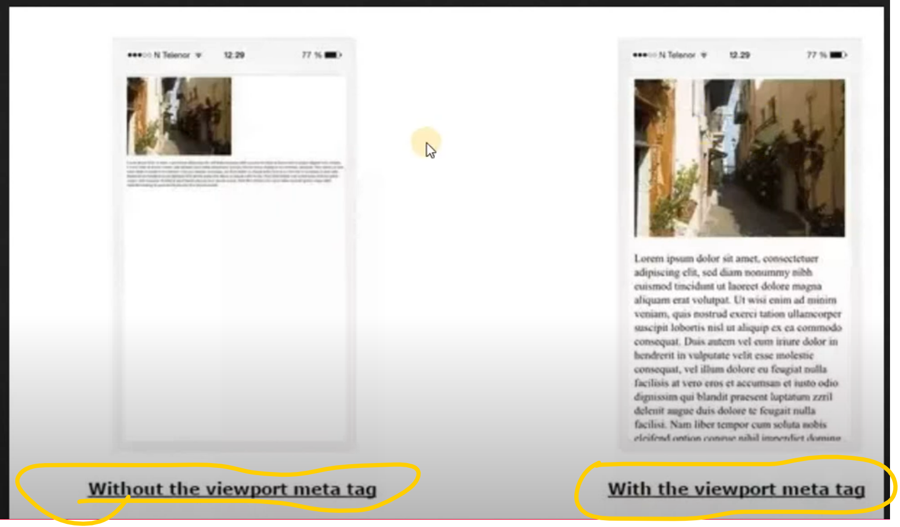

1. RTL: to show some text right to left we use **dir** attribute of html tag just set **dir=”ltr”** or **dir=”rtl”.**
2. HTML validation: to validate html code we can use w3c school website where we can validate our website using url (using this we can validate all website) then single page. [**https://validator.w3.org/**](https://validator.w3.org/)

**CSS**

1. **CSS syntax:**

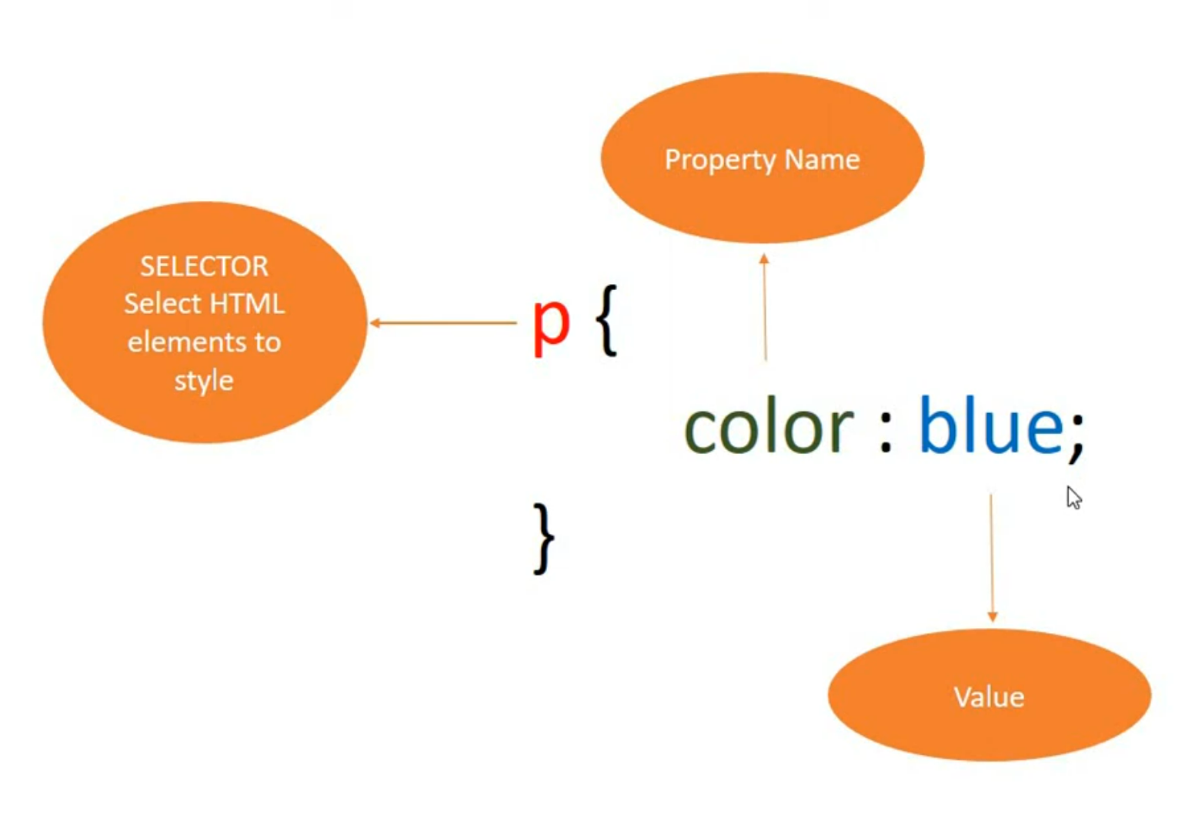

1. **CSS selector:**
2. Id selector (#{})
3. Element selector (P{})
4. Class selector (.test-css{})
5. **ID -> Class -> element**
6. **In CSS color can be specified using:**
7. Predefined colors
8. RGB – (0,0,0)- 0-255
9. **RGBA – this is used to show color as well as transparent label. Suppose if we want to show some color but want to show some image in background as well. Then we generally use RGBA here A represent alpha. Eg: rbga(200,0,88,0.1) here start 3 numbers represent colors and last represents transparent value which used to be 0.1 to 1.0.**
10. **HEX**
11. HSL
12. HSLA
13. **Background:**
14. **background-color:** yellow;
15. **background-image:** url(‘images/1.jpg’);
16. **background-repeat:** no-repeat; **=> There are different values for background repeat, these are:**
17. repeat: (Default)
18. no-repeat
19. repeat-x (mean repeat towards Y-axis means Horizontal repeat)
20. repeat-y (mean repeat towards Y-axis means Vertical repeat)
21. **background-position:** right top; => There are different values for background-position here first part is x-axis and second part is y-axis eg- right is x-axis and top is y-axis:
22. right top
23. right bottom
24. right center
25. center center
26. 50px 100px: position in pixels here 50px x-axis and 100px in y-axis
27. 50% 100%: here position in % where first part is x-axis and second part is y-axis
28. **background-size:** cover; => There is following properties for background-size:
29. cover: it will fill all screen with single image without repeat
30. contain: If used this then image will be not distorted but image should be of proper size
31. 50px 20px
32. 50% 100%
33. **background-attachment:** fixed; => There are following properties for this background-attachment:
34. fixed
35. scroll: (Default)
36. **border:**
37. **border-style:** there are multiple property for border-style:
38. none (default)
39. solid
40. dotted
41. dashed
42. double
43. groove
44. outset
45. inset
46. ridge

Note: border-style: solid dotted none double; => We can use all 4-side property as well it works clock wise means **UP**, then **right** then **down** then left. And if we use only 2 properties then first one is for top and bottom and another one will be considered for left and right.

1. **border-width:**

border-width: 5px; we can specify only one and it will be applicable for all four sides or we can give all four properties separately (**border-width: 5px 2px 5px 6px**) or we can give only 2 properties (**border-width: 5px 2px;**) which will consider as first property for top and bottom and rest 2 are for left and right.

1. **border-color:** this is used to apply color for all sides of borders. Here also we can use all 4 properties for all the sides or single property for all side and 2 for top and bottom as we are using for border-width and style.
2. **border:** we can use all the above property at a time using border property.

border: 5px solid green;

1. **border-radius: This property is used to give curves in border. And same is applicable for this one as well means either we can use single parameter or use 2 parameter or all 4 parameters.**
2. **margin:**

We can align some div in centre using margin as well, to do that we can use **auto** property of margin. Suppose we have fixed some element width and now I want centre that element then we have to use **margin: auto;** and now if we want to give top and bottom some margin after centre then we can we **margin: 20px auto;** here as we know that if we give 2 properties to css the generally it specifies top and bottom and next specify left and right.

**Margin-collapse:** As in margin property of 2 element we can specify 1 element as **Margin-bottom:50px** and below element as **margin-top:30px;** in this case final margin will for these 2 elements will be **50px** not **80px**, means browser will consider bigger value. This is called as **margin collapse**.

1. **Box Model:**

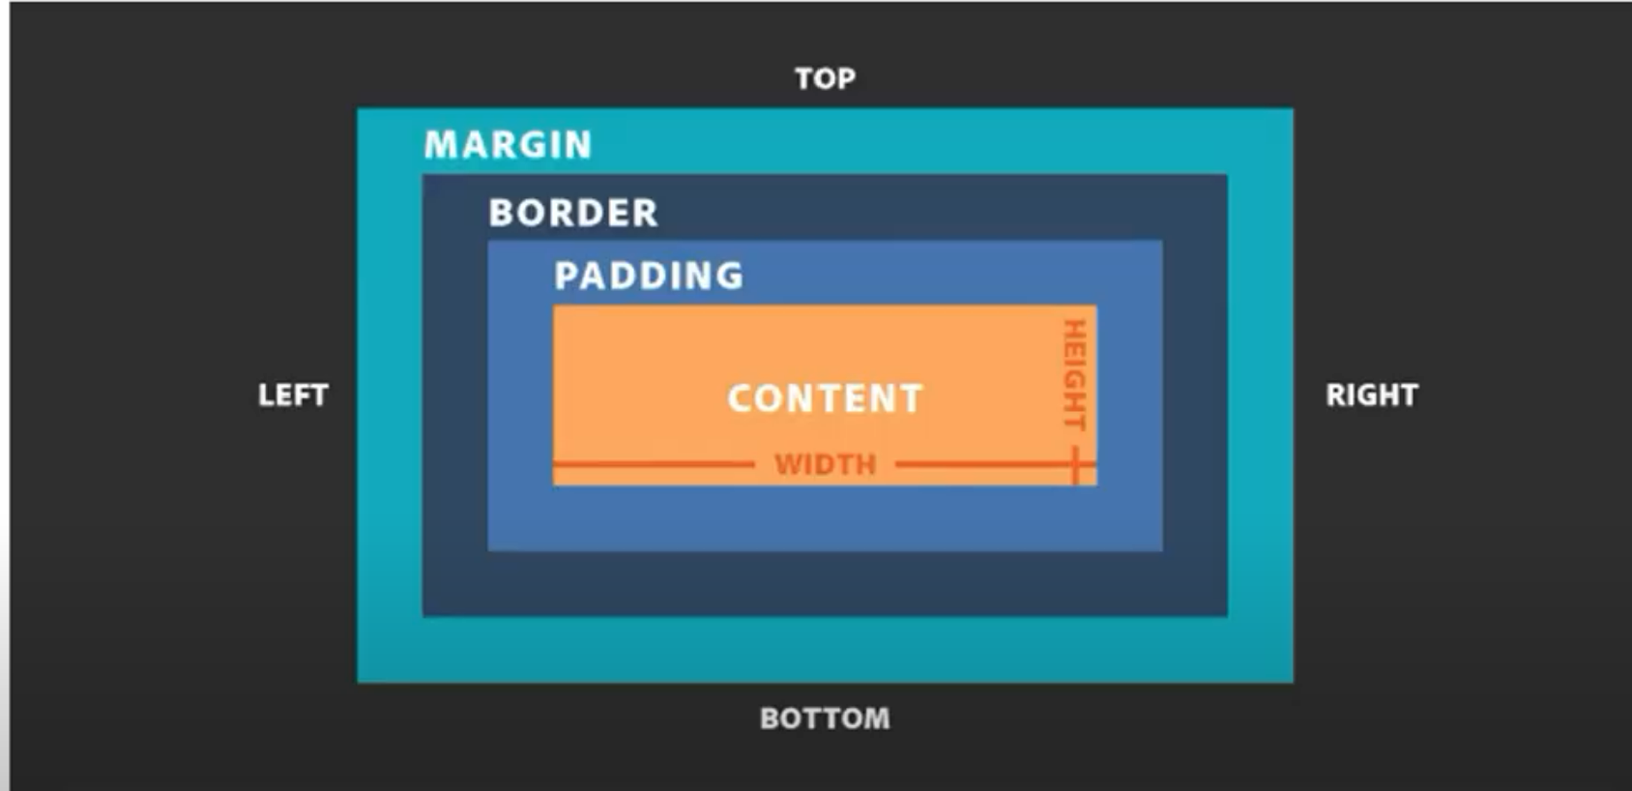

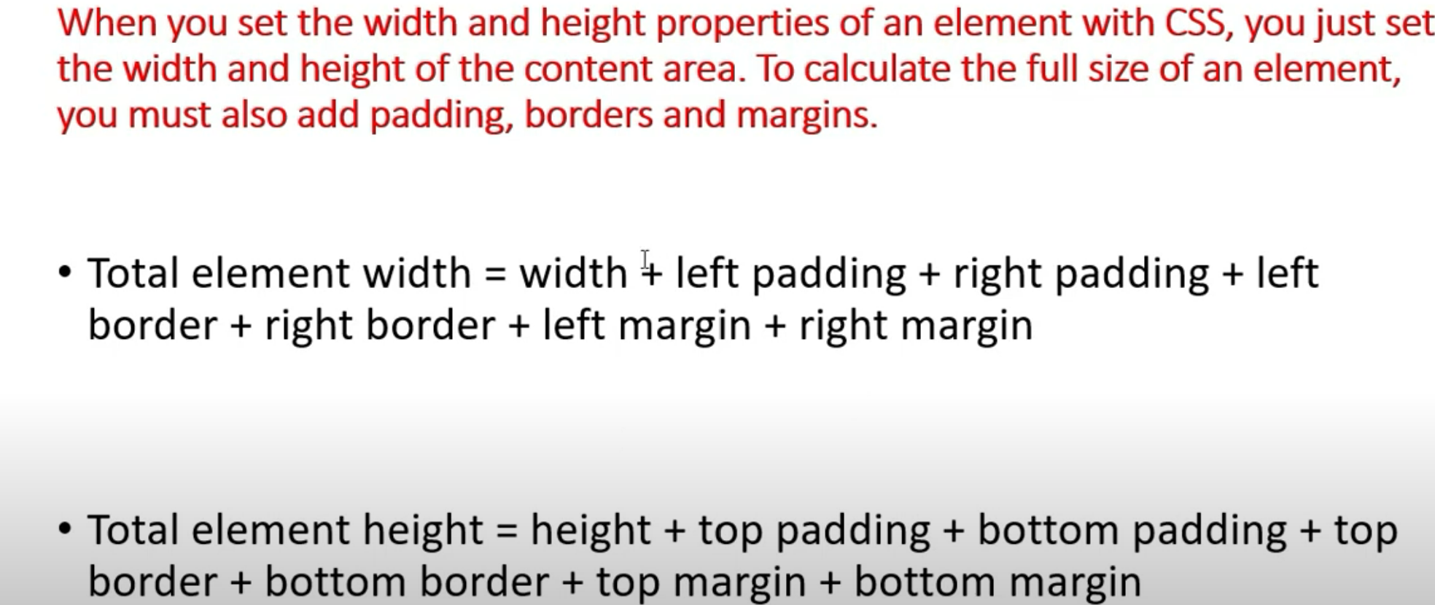

1. **Text:**

There are below property for text:

1. color
2. text-align (left, right, center, justify-to take all available space)
3. direction (ltr, rtl)
4. vertical-align
5. text-decoration (underline, overline, none (default), line-through)
6. text-transform (uppercase, lowercase, capitalize)
7. line-height
8. text-indent
9. letter-spacing
10. word-spacing
11. white-space (normal(default), pre (if used this property then it will print on browser same as we have given in html), nowrap)
12. word-wrap (break-word)
13. text-shadow: 5px, 10px, 5px, red; (horizontally, vertical, blur, color)
14. writing-mode (vertical-lr, vertical-rl)
15. **link:**

a {

text-decoration: none;

}

a:link {

color: yellowgreen;

}

a:visited {

color: black;

}

a:hover {

color: orange;

}

a:active {

color: red;

}

Note:

1. In place of a we can give **id property** as well generally we use id if we have more than one anchor tag.
2. If we use **hover** alone then fine and if we are using **hover** with **link** and **visited** then **link and visited should be on top** of **hover** and **active will be always in bottom.**
3. **Font:** (commonly used font format on website ttf, otf, woff)
4. font-size
5. font-weight (bold, regular(default), 100-900, ) this depends of font as well.
6. font-style (italic)
7. font-variant (normal(default), small-caps)
8. font-family: ‘railway’, sans-serif; - first copy link from embed tab and copy link in head tile

**To add downloaded font in css file:**

**@font-face** {

font-family: **abc**;

scr: url(‘’);

}

Now to use this font in selector we need to write:

Font-family: **abc**;

**Note: In css if we are using single word then its optional to use quote(“”) else we will have to give cotes.**

1. **Units:**
2. We use length in width, height, margin, padding and font-size
3. There are 2 types of units in CSS:
4. Absolute
5. Relative
6. **Absolute Unit in CSS**
7. cm
8. mm
9. in (in)
10. px (1inch = 96px this may verry screen to screen) generally 1 dot of screen
11. pt (1inch = 72pt)
12. pc (1pc = 12pt)
13. **Relative Unit in CSS**
14. em – Relative to size of its direct parent. It generally multiplies its size with parent. Suppose we have given 2 em to one element and its parent size is already 2 em so effective will be 4. If we want to reduce then give 0.5.
15. rem – rem is relative to root (html tag) size
16. vh – 1% of view port height (viewport height)- vvi
17. vw - 1% of view port height (viewport width)-vvi
18. %
19. **Cursor**:

We can **cursor** property of CSS.

1. **Important**:

To priorities the css, this not recommended to use, this generally we use when we use external library. **!Important**.

1. **Box-shadow:**

box-shadow: 10px 20px 5px 5px red; (x-axis, y-axis, blur-radius, shadow-color, spread-radious(optional))

1. **Opacity:**

We can use property to make the content opaque, we generally give value in 0-1

1. **Filter:**

We can use filter with following properties:

blur(50px), brightness (50%), contrast(70%), drop-shadow(), grescale(20%), huerotate(90deg), invert(50%)

**Img {**

**filter: blur(10px), brightness (50%);**

**}**

1. Gradient:

If we mix more than one color then this is called as gradient.

If we want to use gradient then we have to use property like:

background-image: linear-gradient(160deg, to bottom right, green, blue);

background-image: radial-gradient(circle, yellow20%, green30%, blue);

1. **Overflow:**

We use this property when content of container is greater than container.

Overflow has following below properties:

1. visible(default)
2. hidden
3. scroll
4. auto

Note: We can use also use:

Overflow-x: hidden

Overflow-y: scroll

1. resize:

This property we use to resize the text area and contents.

Properties:

1. Both (it will resize horizontal and vertical both)
2. Horizontal
3. Vertical
4. Functions:
5. Calc(); - To perform mathematics calculations
6. Var(): To access the variables
7. **How to declare variable in CSS:**

**:root {**

**--primary-color: blue;**

**--btn-color: yellow;**

**--text-color: green;**

**}**

**In CSS to declare variable we need to define inside :root{} and variable name will always starts with --. And we can access this variable using var(--variable_name) functions.**

1. box-sizing:

As we know by default if we add padding, margin or border then generally container size is getting increasing but if we want fix the box size mean even we add padding margin or border then box size should not increase then we have to use box-sizing. There are following properties for this box-sizing:

1. content-box: (default)
2. border-box
3. Initial vs Inherit:

As per this css property we will use initial then default color will be use means like link default color is blue then in case of initial it will shown as initial and Inherit mean it will take color property from its parent.

1. Object-fit:

This property is used for image and videos to adjust the quality. There is following property for object fit:

1. contain
2. fill
3. cover
4. Pseudo-classes:

In css we have different class for multiple properties like we have for links, like after click, hover etc same like for **li** also for more details please search on google.

Generally we use single : in pseudo class.

1. Pseudo-element:

We generally use Pseudo element to style first letter or specific portion or to insert something in before or after. We use :: (2 colons).

p::first-letter {

color: red;

}

h1::before{

content: url();

}

h1::after{

content: “Some text”;

}

**::selection {**

**color: red;**

**background:yellow;**

**}**

**If we use only:: means this is global element and all the selected text will be in red and backgound will be yellow.**

1. **Display property:**

There are following below properties for display-property:

1. block
2. inline
3. inline-block
4. none

As we know there are element which have default property as inline and there are some elements which default property is block but **we can change it default block or inline by using display-property css**.

* Behaviour of block and inline elements:
* **Block**

1. Starts with new line
2. Takes full width
3. We can apply height and width

* **Inline**

1. Not starts with new line (eg- a tag and span)
2. It did not take full width
3. We cannot apply height and width

* **Inline-block**

1. Not starts with new line (eg- a tag and span)
2. It did not take full width
3. But here we can apply height and width

Note: Means inline-block takes all the property of inline but it also takes height and width.

* To use this css property we have to use display property eg: **display: inline;**
* **visibility: hidden vs display: none, If we use display: none then element will be hidden and there will no space consumed but in visibility: hidden we cannot see element but it will take that space on UI.**

1. position property:

It defines the position of elements on browser. There are 4 type of position property:

1. Static (default) – normal flow
2. **Relative** – with relative we will have to use top, bottom or right and left property then it will always calculate its property from its own position and it will always occupy it original place it will not allow another component to occupy it position like absolute.
3. **Fixed –** This property is used to fixed the element position we can rest part of page can scroll but that particular part will be fixed eg- chatbot option used to be fixed. We will have to use top, bottom right and left properties as well.
4. **Absolute –** With this also all 4 properties are applicable but always start it calculation with its positioned parent if nearest parent is not positioned (static is not considered as positioned it must be fixed relative of absolute) then it will look for its next parent eg- last will be body.

There are 4 more property to define position but it will only use it above 4 used:

1. Top – top: 50px; means from top 50px;
2. Bottom – bottom: 50px; means from bottom 50px;
3. Left – left: 50px; means from left 50px;
4. Right – right: 50px; means from right 50px;
5. **Z-index:** This always worked with positioned elements like absolute, relative or fixed this property is to **change the layer of element**. This works on number, if number high then it will go more high
6. **Float and clear:**

Float is used to shift element left and right. And some times if we use **float then element will outside of box then in this case use overflow:auto;** and clear used to clear specific position of floated element.

1. **2D transforms:**

Using this 2D transform we can rotate, move, scale or skew. To apply 2d transform we use CSS property transform but this transforms property does not work with inline element only work with block or inline-block, we will have change display property inline-block to inline property then only this transform will work.

There are multiple functions of transform:

1. translate (distance from x-axis, distance from y-axis): translate (50px, 50px)
2. rotate(degree): rotate(20deg);
3. scale (multiply with current width, multiply with current height): How much we want to increase or decrease the size of element. – scale (2,3); /scale (0.5,3); we can use only X-axis specific or Y-axis specific eg **scaleX(2)** or **scaleY(3)**;
4. skew(x-axis deg, y-axis deg): skew(20deg, 10deg)- skewX(20deg), skewY(20deg)
5. transform-origin: x-axis in percentage, y-axis in percentage;
6. **3D transform:**

To do 3D transform we use perspective(px) and rotate3d(x-axis, y-axis, z-axis, deg) methods with transform only. We generally use translate3d property as well.

translate3d(x-axis, y-axis, z-axis)

1. **Transition:**

When we change any element property on some event like hover then to change element smooth movement like animation called transition.

There are following property used for transition:

1. Transition-property: css property like with or background-color, we can specify multiple property using comma separated;
2. Transition-duration: 1s;
3. Transition-delay: 500ms;
4. Transition-timing-function: ease-in-out;
5. **Animation:**

To animate anything css provides us one property @keyframes.

@keyframes keyframe_name {

from { background-color: red;}

to {background-color: yellow;}

}

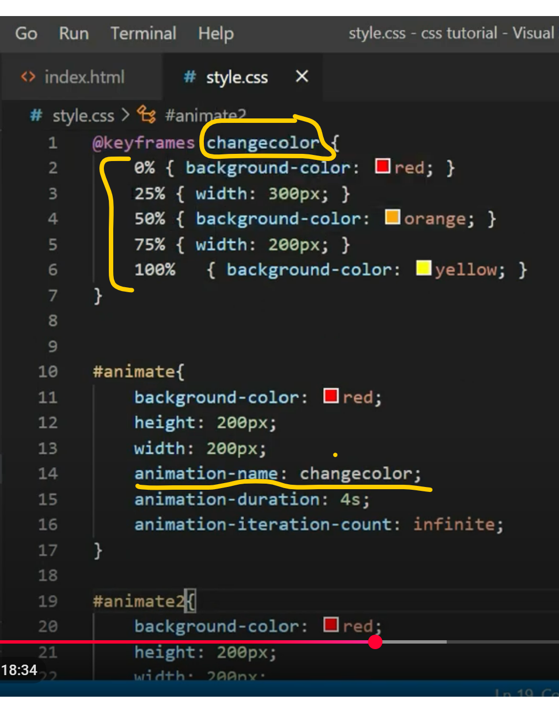

1. **Print:** We can specify the design of print specific pages using @media.

We will have to specify for @media screen {} @media print {} first screen one media is for screen and another one is for print.

1. **Responsive web design:**

If we are not using any CSS framework then to make any web page responsive, we have to use **viewport meta** type, **media query** and making images and video responsive.

**Viewport meta:**

<meta name=”viewport” content=”width=device-width, initial-scale=1.0”>

**Media query:**

@media screen and (max-width: 768px) {

}

**To check actual screen size, we can use website: onlineutilitywebsite.com/my-brower-size**

Note:

1. Responsive design should be mobile screen first.
2. After 768 screen size start for ipad
3. After 400 screen size mobile screen starts
4. We have min with as well as max-width and we can use both at a time to specify width of device screen size
5. **To make image and video responsive we can use below css properties:**

**img {**

**width: 100%;**

**height: auto;**

**}**

**video {**

**width: 100%;**

**height: auto;**

**}**

1. **CSS frameworks:**
2. **Bootstrap**
3. **Skeleton – very light weight**
4. **Pure css**
5. **Foundation css**
6. **Advance CSS Selector:**
7. Attribute selector:

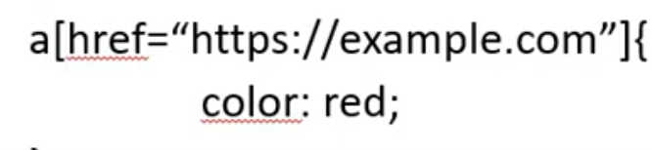

1. Universal selector:

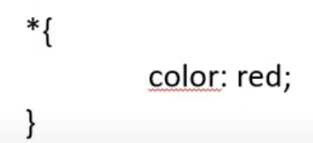

1. **Combinator selector:**

There are 4 types of combinator selector

1. Descendant combinatory (child at any stage):

.red-p span {

Color: red;

}

In above descendant combinatory css we separate element with class with **space** here **red-p** is a class. Here in red-p class if there is any span then apply css to all the span under **red-p** class.

1. Child combinator (Direct child):

In child combinator css will be applicable to only direct child and here we are using > to separate css class and element.

.red-p > span {

Color: red;  
}

1. Adjacent combinator (right after sibling):

.red-p + h1 {

Color: green;  
}

In this we use + and here it will apply css to just after h1 red-p h1.

1. General sibling combinatory (all sibling):

.red-p ~ h1 {

Color: green;

}

1. We can use , (comma) to specify multiple elements.
2. **Specificity in CSS**

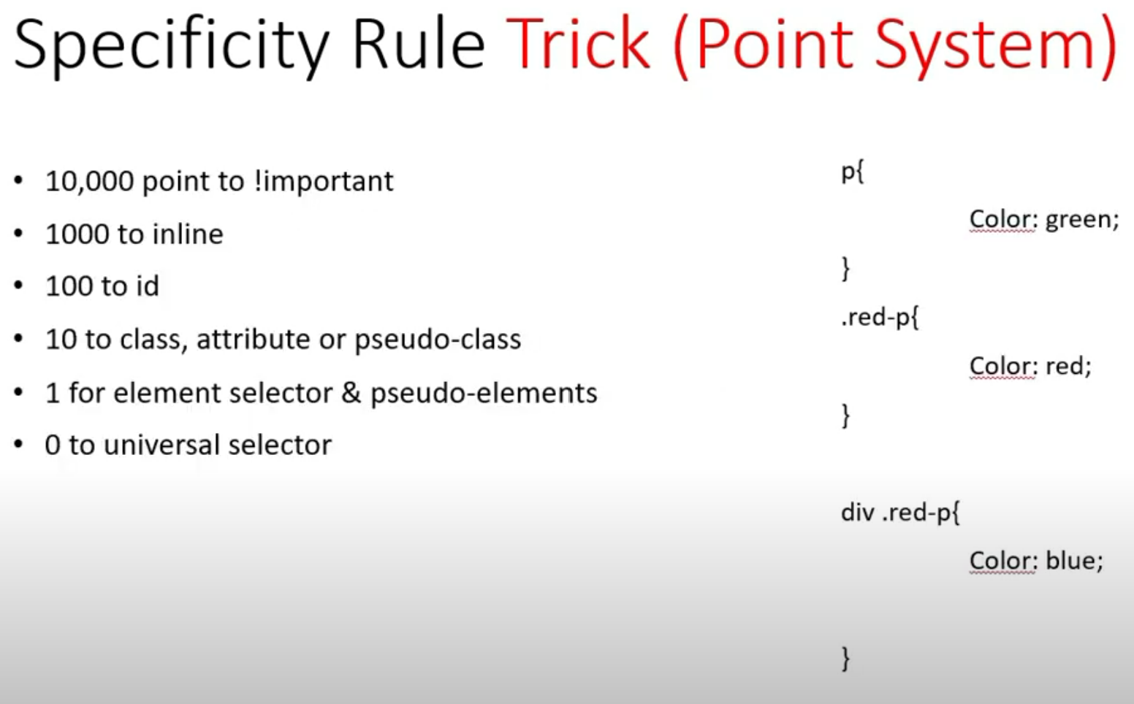

1. Multiple columns in div and css:

We can use below properties in columns:

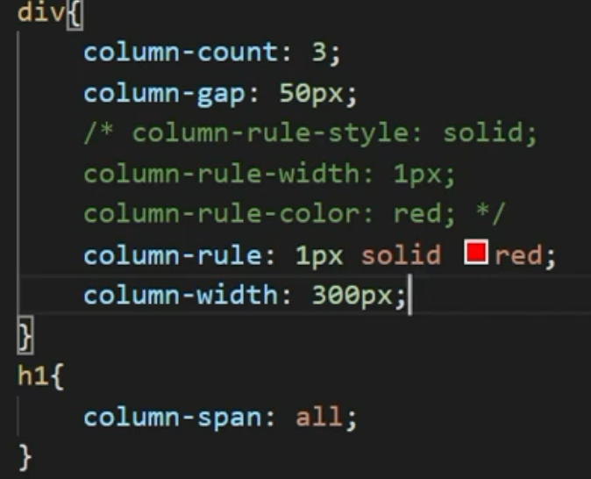

Output:

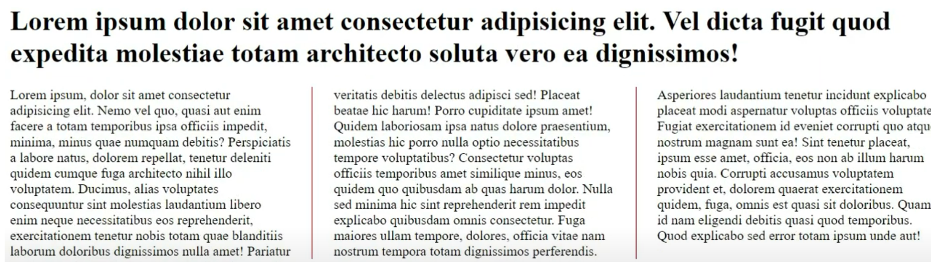

1. Flex: (display: flex)

When we are using flex then almost all designs used to driver from parent CSS.

There are multiple properties for flex:

1. Flex-direction: Default flex-direction is row we can set it to column as well.

Flex-direction: column;/ flex-direction: row; (default)

1. We can align content in flex by using **justify-content** default value is **flex-start**;
   * Flex-start: Item will be place at start
   * Flex-end: Item will be pushed to end
   * Center: Item will be aligned to center
   * Space-between: This property will evenly distribute the items like below:

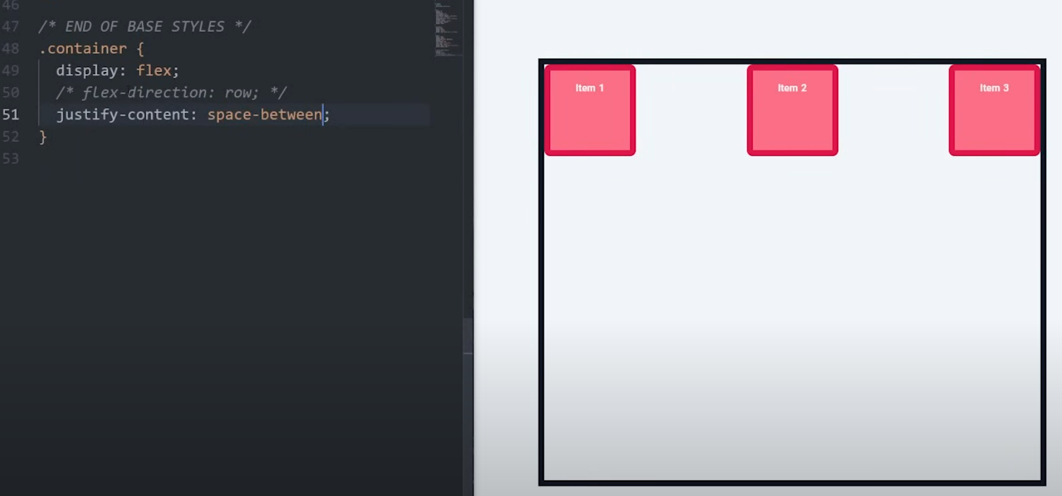

* + Space-around: It is similar to space-between but now edges will also have some spaces.

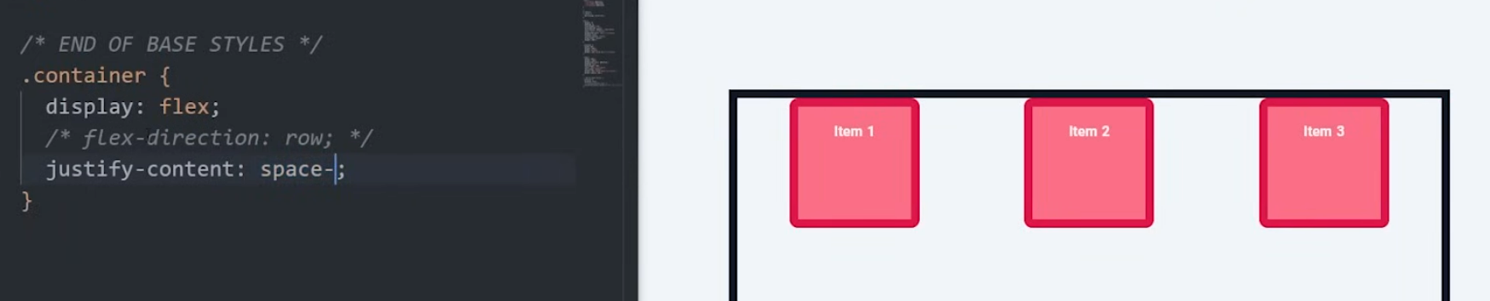

* + Space-evenly: It evenly distribute space between elements.

1. Align-item: It align item vertically, there are multiple properties for this:
   * Flex-start: This is default
   * Flex-end: It will place the item at end

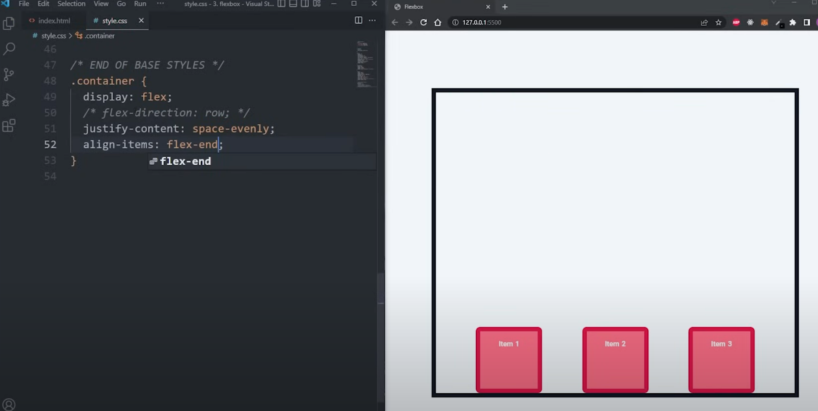

* + Flex-center: Its center item at middle of y-axis

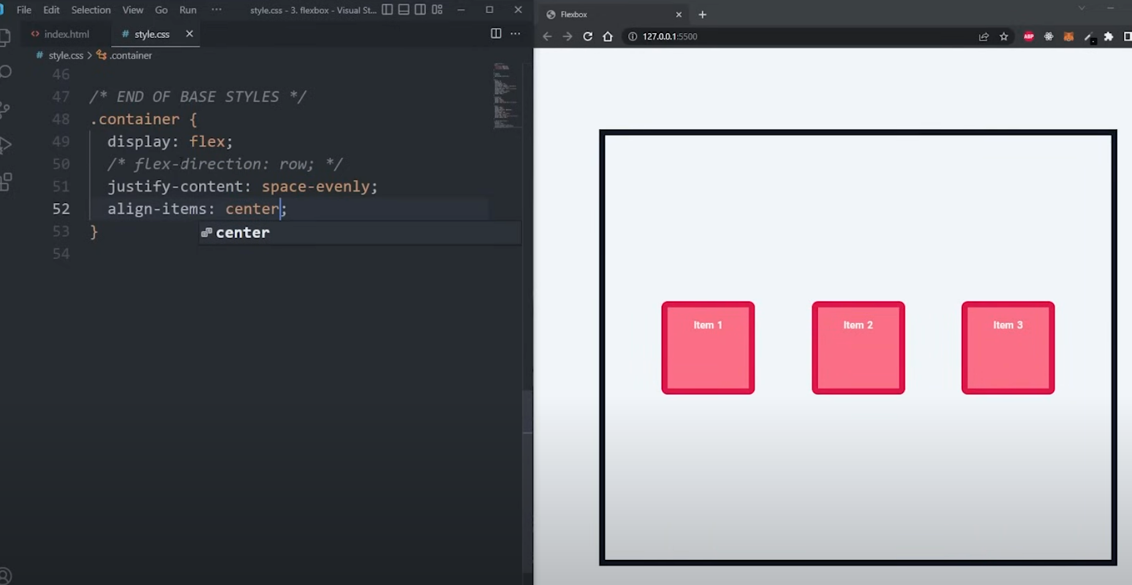

* + Baseline: If we use this property then for each item base line text of each item will be aligned.

1. Flex-wrap: If we will use wrap then if more space required then box will move to next line
2. Align-content: If we use this flex-wrap as wrap then this property we can use by setting value flex-end, center, space-around etc.
3. Gap we can also use to give gap between items gap: 1rem;

**Now child specific properties we can use these below properties with each item:**

1. Flex-grow: 1;
2. Flex-shrink: 1;
3. Flex-basis: 200px;
4. Flex: This is short hand for above all properties but 2nd and 3rd parameters are optional.
5. Align-self: flex-start, flex-end, baseline
6. Order: 1, -1;
7. Grid: **display: grid - https://www.youtube.com/watch?v=EiNiSFIPIQE&ab_channel=SlayingTheDragon**